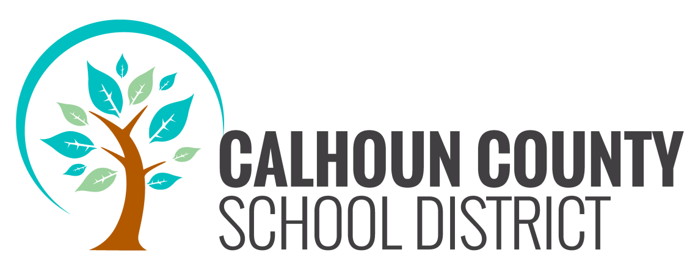

REGULAR BOARD MEETING
JULY 21, 2016
5:00 P.M.

AGENDA

1. CALL TO ORDER
2. ROLL CALL
3. PRAYER/PLEDGE OF ALLEGIANCE
4. SPECIAL ANNOUNCEMENTS:
a. Cards will not be allowed to be picked up after 5:15
(agenda items and or non-agenda items).
b. You have the opportunity to make comments at the
end of the meeting.

5. ADOPTION OF AGENDA
6. PRESENTATIONS: Clarification of Issues—Sally Gadson
Robyn Parrish-Hill—Local Beauty Queens

7. PUBLIC COMMENTS: Public comments are limited to 3 minutes as per Calhoun County School Board Public Participation Policy.

8. APPROVAL OF MINUTES: June 9, 2016 Regular Board Minutes

9. FINANCIAL REPORTS
a. Vouchers Payable, Appropriations,
Expenditures Ledger & Budget Amendments
b. Monthly Financial Report for the Month of June 2016

10. APPROVE TENTATIVE BUDGET FOR ADVERTISING

11. PERSONNEL RECOMMENDATIONS

12. DANNY HASSIG
1. Rescind the previous adopted motion to create a position for Director of Human Resources and Employee Relations

2. Notice to modify or amend the motion to create the position for Director of Human Resources and Employee Relations

13. FACILITIES UPDATE
a. Altha School Construction Update
Altha School Change Order #6
b. BMS Roofing Update

14. PROJECTS, PLANS AND AGREEMENTS
a. Title I, Part A—Vicki
b. Title II, Part A, Teacher & Principal Training—Vicki
c. Adult School Grant—Vicki
d. Florida Virtual School MOU—Vicki
e. PAEC Virtual Franchise (17-035)—Vicki
f. Virtual Instruction Program Policies and Procedures--Vicki
g. Contract with PAEC for VAM Calculations (17-097)—Vicki
h. SRO Contract with the Calhoun County Sheriff’s Department—Vicki
i. SRO Contract with the City of Blountstown—Vicki
j. Gaetz Aerospace Institute, Embry-Riddle Aeronautical University—Vicki
k. North Florida Child Development MOU—Vicki
l. District Participation in the Panhandle Area Educational Consortium—Elaine
m. PAEC Professional Development Center (PDC) Resolution and
Contract for District Participation—Elaine
n. PAEC Student Data Services Resolution and Contract for District Participation—Elaine
o. Gateway Educational Computing Consultants Project Resolution and Contract for District Participation—Elaine
p. Performance Contract for Exceptional Student Education Consultative Services—Staci
q. 2016-17 IDEA Part B, Entitlement Budget and IDEA Part B, Preschool Budget—Staci
r. 2016-17 Letter of Agreement Between Calhoun County School Board and Accelify—Staci
s. Cooperative Agreement with Calhoun County Health Department for Registered Nursing Services for the 2016-17 School Year—Staci
t. 2016-17 Cooperative Service Agreement with the Louise R. Goldhagen Multidisciplinary Evaluation and Consulting Center of Florida State University—Staci
u. State of Florida Voluntary Prekindergarten Education Program Statewide Provider Agreement for the 2016-17 School Year—Staci
v. Cooperative Agreement with Focus on Behavior, Inc. for Behavioral Services for the 2016-17 School Year
w. Cooperative Agreement with Children’s Psychological Services Center, Inc. for School Psychology Services for the 2016-17 School Year—Staci
x. Cooperative Agreement with Psychological & Educational, PLLC, Brian Boehman, Ph.D. for School Psychology Services for the 2016-17 School Year—Staci
y. Cooperative Agreement with Larry M. Kirkland, Inc. for the 2016-17 School Year—Staci

z. Cooperative Agreement with Myla Wahlquist, PT for Physical Therapy Services for the 2016-2017 School Year

15. OUT-OF-DISTRICT STUDENT TRANSFERS

16. PARENT/STUDENT HANDBOOKS:
Blountstown Elementary Carr Elementary/Middle School
Blountstown Middle School Care/ALC
Blountstown High School Pre Kindergarten
Altha Public School

17. PARENT GUIDE

18. CODE OF CONDUCT

19. EMPLOYEE HANDBOOK

20. SUPERINTENDENT REPORT:
a. School Grades Update
b. Countywide Meeting
c. BHS for Community Eligibility Program

21. EMERGENCY ITEMS:

22. ANNOUNCEMENTS AND COMMENTS

Additions in Blue Deletions in Red

